SIMATS ENGINEERING (SAVEETHA SCHOOL OF ENGINEERING)

Department of Computer Science and Engineering

ASSESSMENT TOOL 3 – Mock Interview

Course Code: | CSA0612 | Course Title: | Design and Analysis of Algorithms
CO Assessed: | CO5 – Naturalization (BL5, BL6) | Assessment: | Assessment Tool 3 – Mock Interview
Weightage: | 30% of CIA | Total Marks: | 100
CO5 Statement: | Analyze computational problems using backtracking techniques and complexity classes such as P, NP, NP-Hard, and NP-Complete for combinatorial problem solving.
Student Name: | DIVYASREE.P | Reg. No.: | 192565016
Section / Batch: | 2025 | Date: | 29/08/2026
Instructions to Students
- Attend the mock interview individually and answer all technical questions clearly.
- Explain the logic, algorithm design steps, and complexity analysis wherever required.
- Demonstrate understanding of backtracking, recursion, and combinatorial problem-solving approaches.
- Differentiate clearly between P, NP, NP-Hard, and NP-Complete problems with suitable examples.
- Maintain clear communication, confidence, and logical presentation throughout the interview.

Question Type | Focus Area | Questions
Mock Interview | Demonstrate problem-solving skills in backtracking techniques and complexity classes through technical discussion and algorithmic analysis. | Q1- Q10

SECTION A – Mock Interview

Code of Conduct
IDIVYASREE.P (192565016) (Name / Reg No) certify that this submission is my original work and that I have adhered to the guidelines specified for this assessment. I understand that any violation of academic integrity rules will result in disciplinary action.
Signature of the Student:

RUBRICS FOR CALCULATION

Criteria | Wt. | Level 4 – Exemplary | Level 3 – Proficient | Level 2 – Developing | Level 1 – Beginning
Technical Knowledge | 25% | Demonstrates strong and accurate subject knowledge with in-depth understanding | Shows good knowledge with minor gaps | Basic knowledge with noticeable errors | Lacks fundamental technical knowledge
Problem Solving | 25% | Solves problems logically and applies concepts effectively in real scenarios | Applies concepts with moderate accuracy | Limited problem-solving ability; requires guidance | Unable to solve or apply concepts
Analytical Thinking | 15% | Analyzes questions critically and provides well structured, logical answers | Provides reasonable analysis with some structure | Superficial or partially structured responses | No analytical thinking demonstrated
Communicati on | 15% | Communicates clearly, confidently, and professionally with proper terminology | Communicates well with minor hesitation | Communication lacks clarity or confidence | Unable to communicate effectively
Confidence | 10% | Displays high confidence, positive attitude, and professional behavior throughout | Shows good confidence with minor issues | Low confidence; inconsistent behavior | Lacks confidence and professionalism
Response to Questions | 10% | Responds accurately, promptly, and elaborates with relevant examples | Responds correctly but with limited depth | Partial responses; needs prompting | Unable to respond appropriately

Marks Evaluation:
Criteria | Wt. | Level 4 – Exemplary | Level 3 – Proficient | Level 2 – Developing | Level 1 – Beginning
Technical Knowledge | 25%
Problem Solving | 25%
Analytical Thinking | 15%
Communication | 15%
Confidence | 10%
Response to Questions | 10%
Total Marks (100):

Faculty In-charge | Course Coordinator | Head of Department
Name: | Name: | Name:
Signature: | Signature: | Signature:
Date: | Date: | Date:

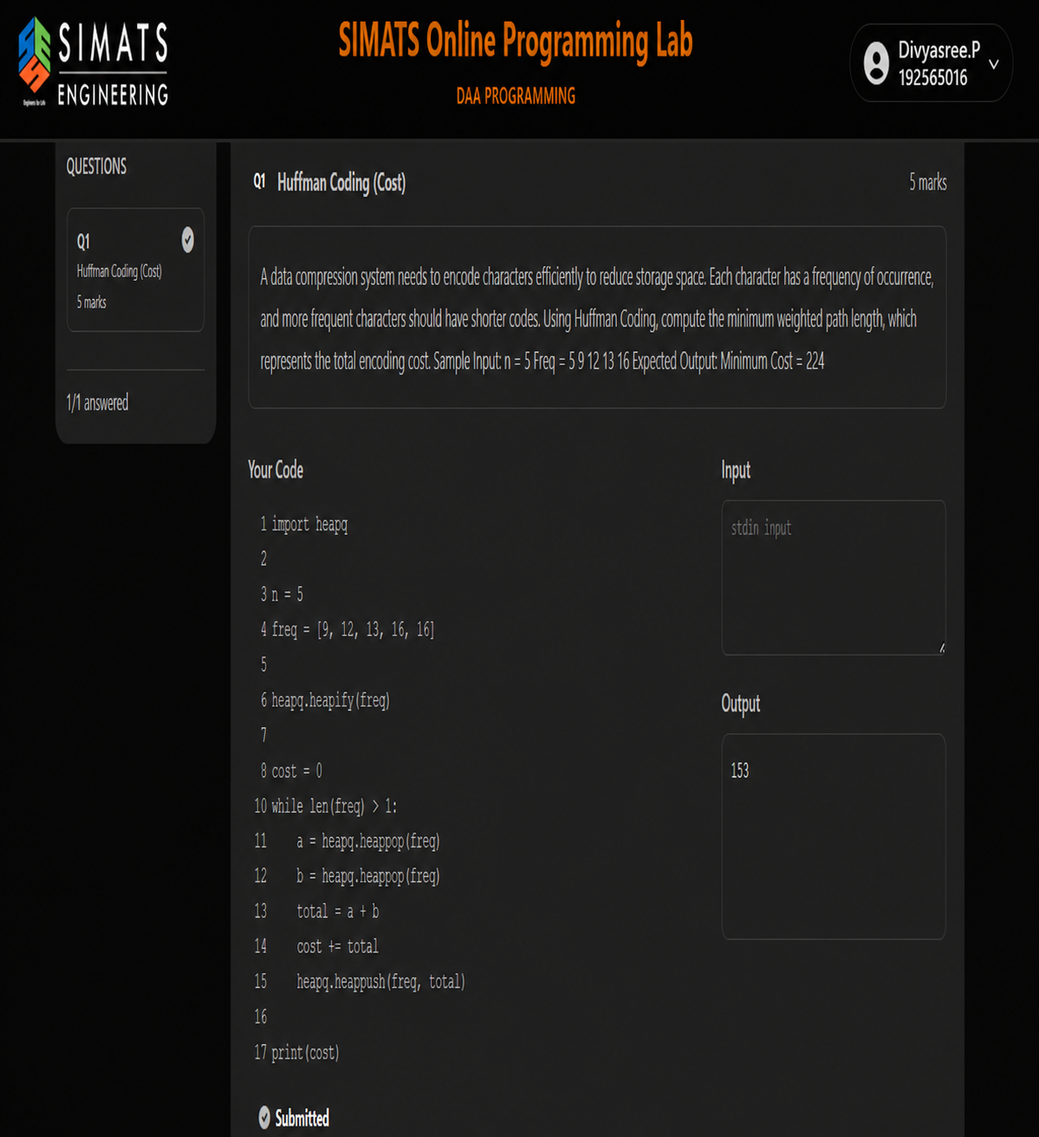

REPORT

1. Introduction

Graph isomorphism is the problem of determining whether two graphs have the same structure even when their vertices have different labels. Two graphs G1 and G2 are isomorphic if there exists a one-to-one mapping between their vertices such that an edge exists between two vertices in G1 exactly when the corresponding vertices are connected in G2. The program shown in the laboratory question is designed as a constraint-based decision procedure for this problem.

2. Problem Objective

The objective is to accept two graphs represented by adjacency matrices and determine whether they are structurally identical under vertex relabeling. The solution must define vertex-mapping and edge-preservation constraints, use these constraints to reject impossible mappings early, and employ backtracking to explore the remaining feasible mappings. The final result is a Boolean decision: True when an isomorphism exists and False otherwise.

3. Constraints Used

The first constraint is the vertex-count constraint. If the two graphs do not contain the same number of vertices, an isomorphism is impossible. The code shown checks this with len(G1) and len(G2) and immediately returns False when the sizes differ.
The second constraint is the degree constraint. An isomorphism preserves vertex degrees, so the sorted degree sequences of both graphs must be equal. In an adjacency matrix, the degree of a vertex is the sum of the entries in its row. The displayed code calculates sorted degree sequences using sorted(sum(row) for row in G1) and the equivalent expression for G2. If the sequences differ, the function returns False.
The main mapping constraint requires every vertex of G1 to be mapped to exactly one distinct vertex of G2. The mapping therefore behaves as a permutation of the vertices. During backtracking, already-used vertices of G2 are excluded from future choices.

4. Algorithm and Backtracking Approach

After the quick feasibility checks, the algorithm constructs a mapping one vertex at a time. For the current vertex of G1, candidate vertices in G2 are considered only when they satisfy necessary constraints, especially matching degree. A candidate is temporarily assigned, marked as used, and the algorithm recursively processes the next vertex.
Constraint checking is performed before continuing the recursion. For every previously mapped vertex u of G1 and its mapped vertex f(u) in G2, the algorithm verifies that adjacency is preserved: G1[u][v] must equal G2[f(u)][f(v)]. If this condition fails, the current candidate cannot lead to a valid isomorphism and the branch is abandoned immediately. This is the key pruning step.

